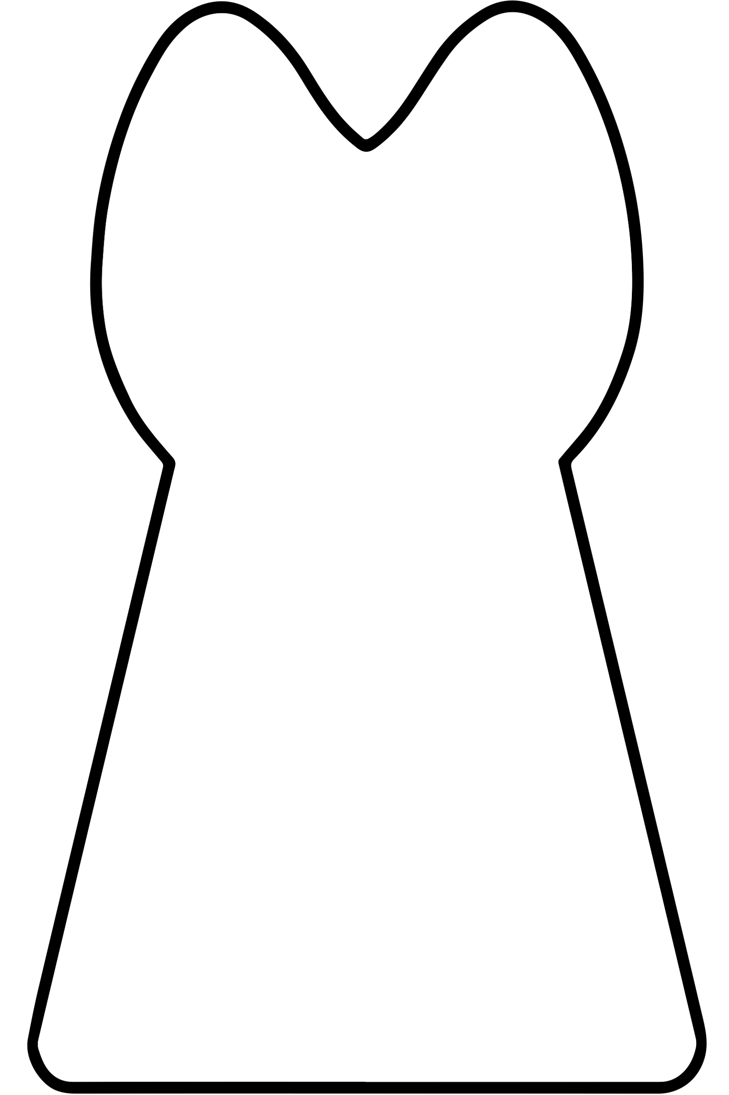

**Name (first, last) of petペットのお名前（ふりがな）:**

**Type of animal:**

This is the application form and *Katashiro* for your pet for Toshikoshi-no-Ōharae. Please follow the instructions then mail application form to us.

**[How to use pet *katashiro*]**

1. Write your pet’s name, address and what type of animal (i.e. dog, cat) on front of the pet *katashiro*.
2. Breathe upon (pet is better but if not, yours ok) the *katashiro*.
3. Wipe pet *katashiro* on pet while saying wishes in your heart.

For example, safety, health etc.

1. Complete application form and select package plan (please refer to other release form).
2. Prepare donation service fee.

**Check:** Payable to Shinto Shrine of Shusse Inari in America

**PayPal:** PayPal@ShintoInari.org; please include the PayPal’s transaction fee.

1. Mail (**to arrive before December 28th**) to Shrine Office.

**Mailing address: Shinto Shrine of Shusse Inari in America**

**8931 W. 25th Street, Los Angeles, CA 90034**

We will hold the *Toshikoshi-no-Ōharae* service on December 31st with your *hitogata* (and/or *katashiro*) and notify you after completion of the service. We will then ship any requested packages.

**祝詞で読み上げますのでハッキリとお書き下さい**

**Please print clearly as we will read them**

**during the service.**

Pet’s Name (first, last) お名前（ふりがな）：

Address ご住所：

Owner’s E-mail address メールアドレス：

Package plan (Please circle) ご祈祷プラン (丸で囲んで下さい) : 　　Hitogata / Kitsune / Inari / Family

Please indicate if it is OK for your name to be read aloud in the service, as the service may be posted on YouTube.ご祈祷中にお名前を声に出して読み上げても良いですか？（ご祈祷はネット公開される場合があります）: **Yes!! No**

The information you provide will only ever be used for services and information from the Shrine.

**年越の大祓Toshikoshi-no-Ōharae**

**Purify for the year - pet-**

**Application form**